Menu |  | - Week 4
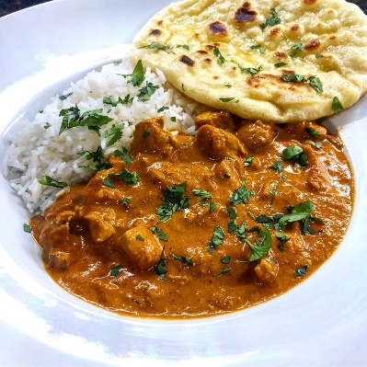  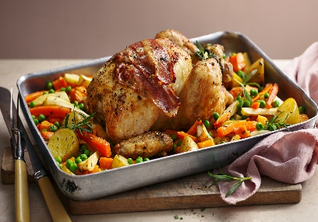  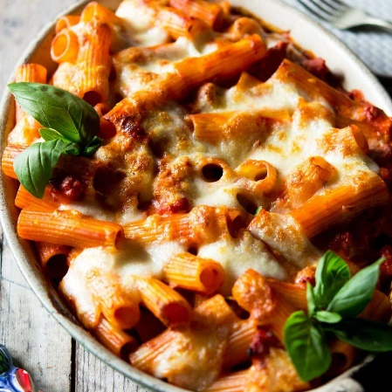  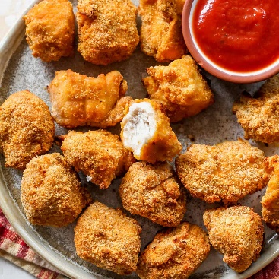 |  | Monday  - Chicken Tikka Served with Rice, Naan Bread, Wedges & Sweetcorn  - Meatball Sliders served with Wedges & Sweetcorn  Tuesday  - Crispy Chicken Taco served with Criss cross potatoes & Pepper Sticks  - Fish Finger Taco served with Criss cross potatoes & Salad  Wednesday  - Roast Dinner Served with all the Trimmings  - Giant Yorkshire Pudding Wrap served with Roast Potatoes & Vegetables  Thursday  - Macaroni Cheese served with Garlic Bread & Vegetables  - Pizza Pasta Bake served with Crusty Bread & Vegetables  Friday  - Chicken Nuggets Served with Chips, Baked Beans or Peas  - Quorn Dippers Served with Chips, Baked Beans or Peas

