Menu |  | - Week 3
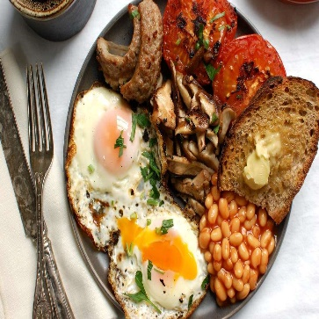  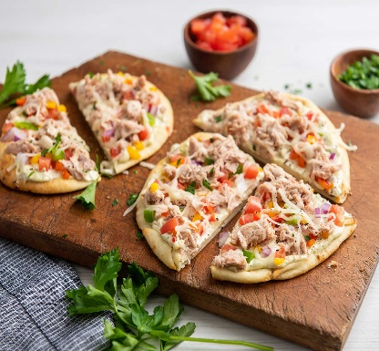  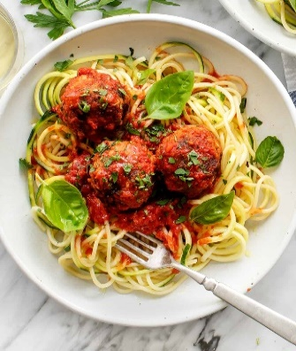   |  | Monday  - Full English Breakfast – Sausage, or Quorn Sausage, Bacon, Scrambled Egg, Tomatoes, Mushrooms, Toast and Baked Beans  Tuesday  - Tuna Melt loaded Pitta Bread served with Wedges and Salad  - Tortilla Wraps with a Selection of Fillings served with cucumber & carrot sticks  Wednesday  - Roast Dinner Served with all the Trimmings  - Hot Roast Beef sandwich served with Criss cut Potatoes & Vegetables  Thursday  - Meatballs in a Tomato sauce served with Spaghetti, Garlic Bread, and Vegetables  - Vegetarian Tomato Sauce Served with Pasta and Garlic Bread  Friday  - Chicken Burger served with Chips and Baked Beans or Peas  - Home-made Pizza Served with Chips and Baked Beans or Peas

