Menu |  | - Week 2
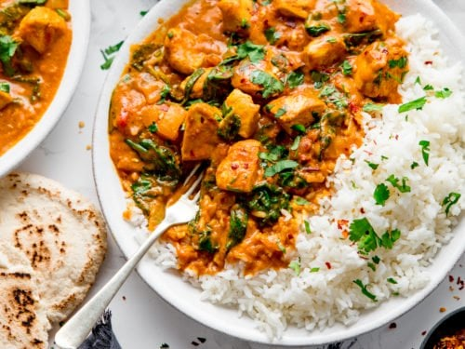  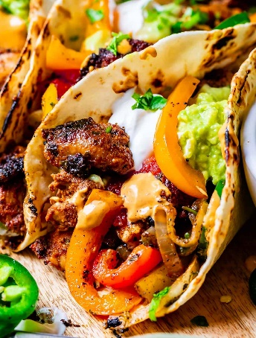  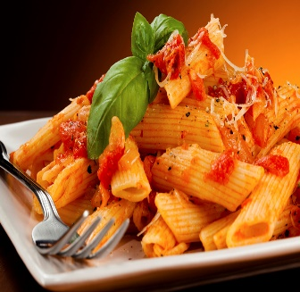   |  | Monday  - Chicken Korma Served with Rice, Naan Bread, Sauté Potatoes and Sweetcorn  - Tomato & Basil Pasta Bake served with Garlic Bread, Sauté Potatoes and sweetcorn  Tuesday  - Chicken Fajita Served with Wedges and Salad  - Macaroni Cheese Served with Wedges, Garlic Bread, and Fresh Vegetables  Wednesday  - Roast Dinner with all the Trimmings  - Oven Baked Sausage Served with Yorkshire Pudding, Roast Potatoes, and Seasonal Vegetables  Thursday  - Spaghetti Bolognaise Served with Garlic Bread and Vegetables  - Penne Pasta Served with Tomato Sauce, Cheese and Garlic Bread  Friday  - Fishfingers Served with Chips, Baked Beans or Peas  - Selection of Pizza Served with Chips, Baked Beans or Peas

