Menu |  | - Week 1
  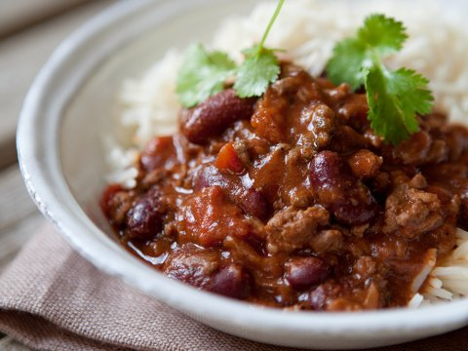  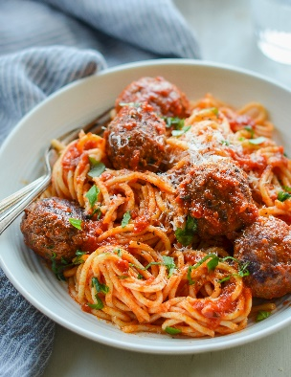  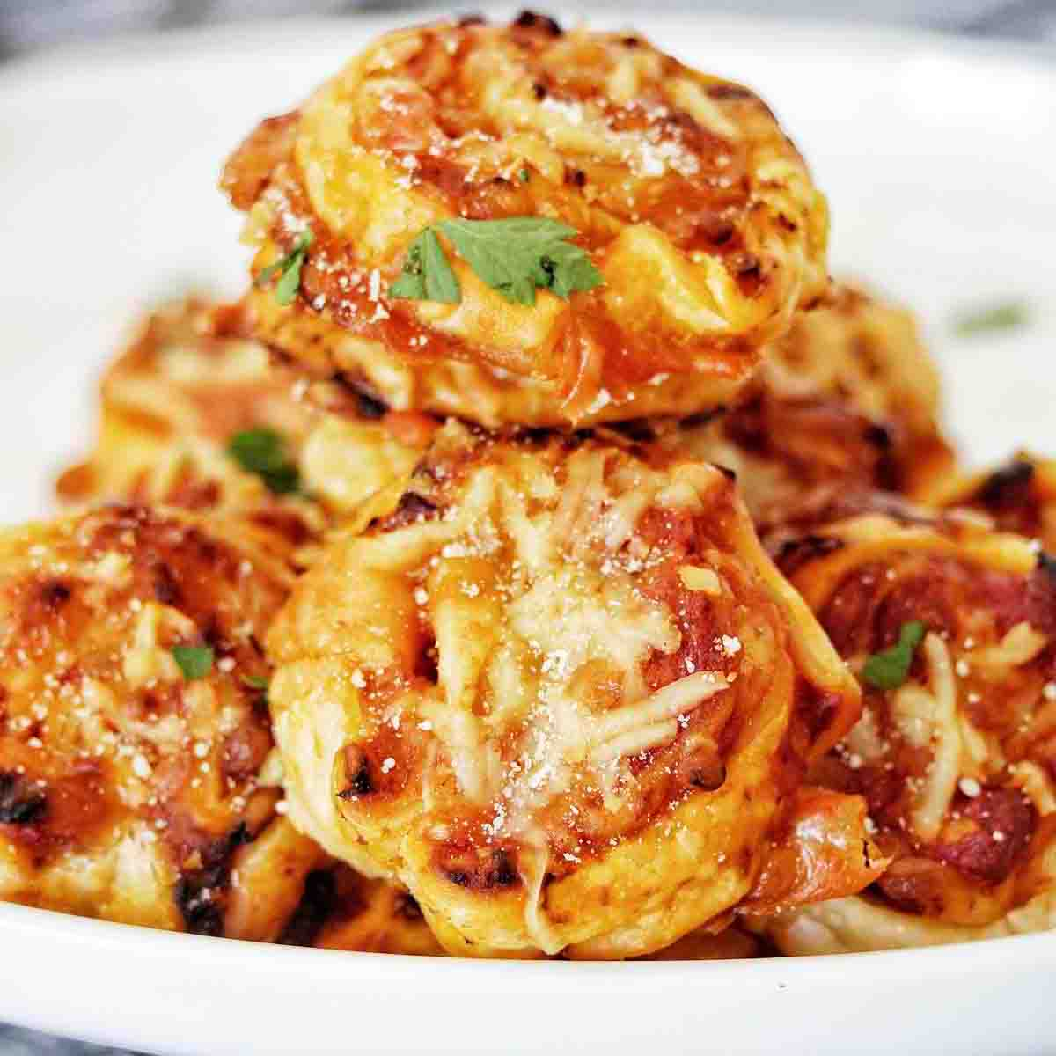 |  | Monday  - Oven Baked Sausage Served with Mashed Potato and Seasonal Vegetables  - Cheese Lattice served with Wedges & Vegetables  Tuesday  - Chilli Con Carne Served with Rice and Crusty Bread & Sweetcorn  - Jacket Potato Served with a Selection of Fillings – Cheese, Beans & Tuna  Wednesday  - Roast Dinner Served with All the Trimmings  - Hot Roast Turkey Sandwich served with Roast Potatoes, Gravy & Vegetables  Thursday  - Tuna Pasta Bake served with Garlic Bread and Seasonal Vegetables  - Meatball & Vegetable Pasta Bake served with Garlic Bread and Seasonal Vegetables  Friday  - Breaded Chicken Dippers Served with Chips, Garden Peas or Beans  - Cheese and Tomato Pinwheels served with chips, Garden Peas or Beans  Friday  Breaded Fish and Chips  ~~~  Thin & Crispy pizza  [Menu Item Name]  [Menu item description.]

